Baseline_imagenet_EfficientNetB0.h5 learning rate 1e-6 50 epoch Contour Crop (210,210,3)

Lowest training loss: 0.3243662416934967

Lowest validation loss: 0.6150691509246826

Highest training accuracy: 0.8767522573471069

Highest validation accuracy: 0.7247956395149231

Thoughtts from loss:

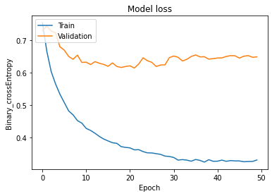

Good learning rate for training loss; High learning rate for validation

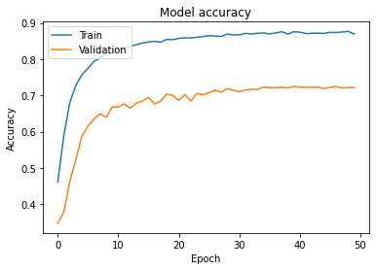

Thoughts on accuracy:

Moderate level overfitting

Baseline_imagenet_EfficientnetB0.h5 learning rate 1e-6 50 epoch High Crop (160, 160, 3)

Lowest training loss: 0.40360748767852783

Lowest validation loss: 0.6022466421127319

Highest training accuracy: 0.8347916007041931

Highest validation accuracy: 0.6986376047134399

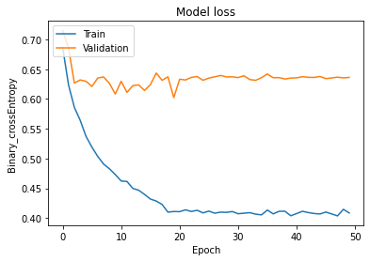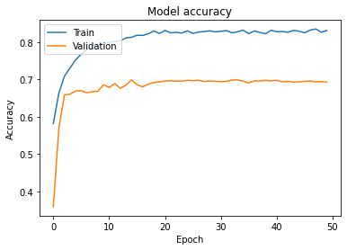

Baseline_efficientNetB0 learning rate 1e-6 200 epoch High Crop (150,150,3)

Lowest training loss: 1.0642935037612915

Lowest validation loss: 1.5395534038543701

Highest training accuracy: 0.6682931184768677

Highest validation accuracy: 0.7155126333236694

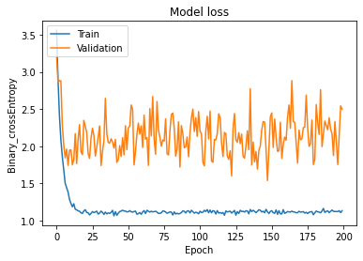

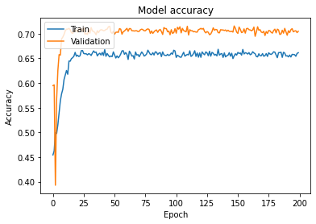

Learning Rate Finder

Training data: 5k instead of maximum 8k

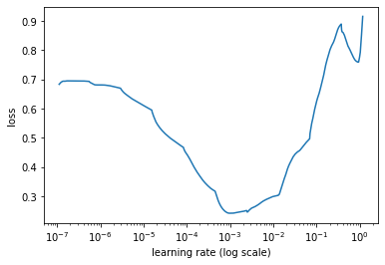

Learning rate finder

Training data: 8k instead of 10k

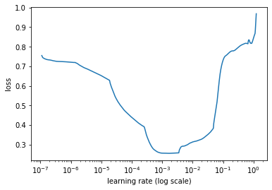

Baseline_imagenet_effiecinetNetB0,

high crops (150,150,3)

epoch 500

Adam(lr=1e-3, amsgrad=True)

loss = 'binary_crossentropy'

ReduceLROnPlateau(monitor='val_accuracy', factor=0.5, verbose=1, patience=5, mode='max')]

Lowest training loss: 0.0003257665375713259

Lowest validation loss: 0.6510282754898071

Highest training accuracy: 1.0

Highest validation accuracy: 0.8152588605880737

Model Link: https://drive.google.com/file/d/1kUJxr64gVRapVqoaXAw-akBXHIL75XOl/view?usp=sharing

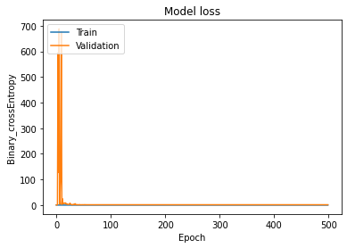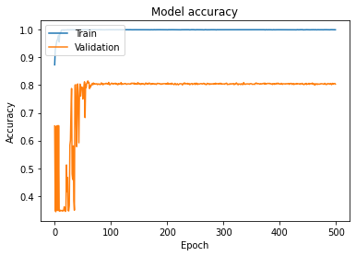

Training With K train

EfficientNetB0 imagenet_weights = true input_shape=(150,150,3),

learner.autofit(0.001, 600, monitor='val_accuracy', early_stopping=True, reduce_on_plateau=5, reduce_factor=5)

Lowest training loss: 0.0839

Lowest validation loss: 0.4738

Highest training accuracy: 0.9699

Highest validation accuracy: 0.8463

begin training using triangular learning rate policy with max lr of 0.001...

Epoch 1/600

263/263 [==============================] - 56s 142ms/step - loss: 0.4362 - accuracy: 0.7970 - val_loss: 0.8481 - val_accuracy: 0.4681

Epoch 2/600

263/263 [==============================] - 34s 130ms/step - loss: 0.1875 - accuracy: 0.9277 - val_loss: 1.2832 - val_accuracy: 0.6454

Epoch 3/600

263/263 [==============================] - 34s 128ms/step - loss: 0.1397 - accuracy: 0.9489 - val_loss: 0.5359 - val_accuracy: 0.8307

Epoch 4/600

263/263 [==============================] - 34s 129ms/step - loss: 0.0882 - accuracy: 0.9650 - val_loss: 0.4738 - val_accuracy: 0.8463

Epoch 5/600

263/263 [==============================] - 34s 130ms/step - loss: 0.0839 - accuracy: 0.9699 - val_loss: 0.6414 - val_accuracy: 0.7670

Restoring model weights from the end of the best epoch.

Epoch 00005: early stopping

Weights from best epoch have been loaded into model.

[11]:

<tensorflow.python.keras.callbacks.History at 0x7f270f73a290>

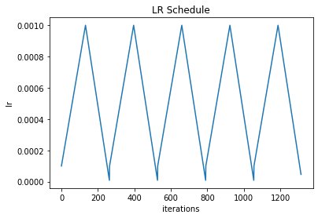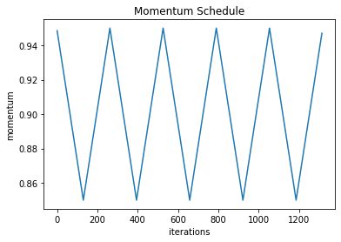

EfficientNetB0, weights imagenet, (150,150,3) 300 epoch, learning rate 1e-3 , factor =0.1, adam

Model location: old pc (EffnetB0_test1.h5)

Lowest training loss: 0.00631455285474658

Lowest validation loss: 0.6622418165206909

Highest training accuracy: 0.9983109831809998

Highest validation accuracy: 0.8040794134140015

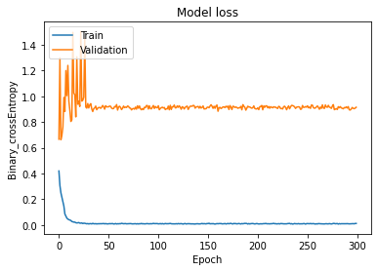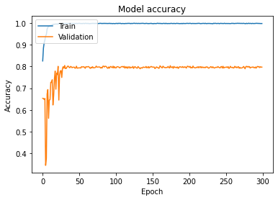

weights imagenet (150,150,3), SGD(lr=1e-3), factor=0.9

Model location: EffnetB0_test2.h5 (old pc)

Lowest training loss: 0.02498202957212925

Lowest validation loss: 0.6032058000564575 (Lowest validation loss ever)

Highest training accuracy: 0.9912733435630798

Highest validation accuracy: 0.7847557663917542

EfficientNetB0 weights imagenet (150,150,3) SGD(1e-3), factor=0.5

Model Location: EfficientNetB0_test3.h5 (old pc)

Lowest training loss: 0.18809080123901367

Lowest validation loss: 0.4624157249927521

Highest training accuracy: 0.9312189221382141

Highest validation accuracy: 0.8040794134140015

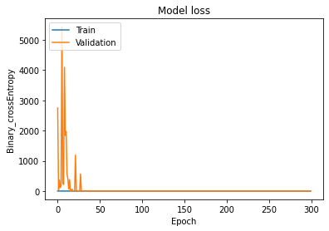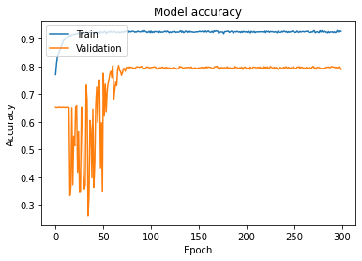

|  |  |  |  |  |  |  |  |  |  |
| --- | --- | --- | --- | --- | --- | --- | --- | --- | --- |
| Model | Crops | Epoch | LR | Loss | Factor | Stats | Location | Test acc | F-1 score |
| Baseline_imagenet_effiecinetNetB0 | (150,150,3) | 500 | Adam(lr=1e-3, amsgrad=True) | loss = 'binary_crossentropy' | factor=0.5 | **Lowest training loss:** 0.0003257665375713259  **Lowest validation loss:** 0.6510282754898071  **Highest training accuracy:** 1.0  **Highest validation accuracy:** 0.8152588605880737 | Google Drive | 0.8174 | 0.8111 |
| EffnetB0_weighted_test1.h5 | (150,150,3) | 500 | Adam(lr=1e-3, amsgrad=True) | loss = 'binary_crossentropy' | factor=0.5 | **Lowest training loss:** 0.0004172975604888052  **Lowest validation loss:** 0.6506848931312561  **Highest training accuracy:** 1.0  **Highest validation accuracy:** 0.8003220558166504 | Old pc | 0.8002 | 0.7906 |
| EffnetB0_weighted_test2.h5 | (150,150,3) | 500 | Adam(lr=1e-3, amsgrad=True) | loss = 'binary_crossentropy', | factor=0.7 | **Lowest training loss:** 8.644914487376809e-05  **Lowest validation loss:** 0.6140548586845398  **Highest training accuracy:** 1.0  **Highest validation accuracy:** 0.8115941882133484 | Old pc | 0.8115 | 0.8068 |
| EffnetB0_weighted_test3.h5 | (150,150,3) | 500 | Adam(lr=1e-3, amsgrad=True) | loss = 'binary_crossentropy', | factor=0.9 | **Lowest training loss:** 2.4064400349743664e-05  **Lowest validation loss:** 0.6654452681541443  **Highest training accuracy:** 1.0  **Highest validation accuracy:** 0.811057448387146 | Old pc | 0.8104 | 0.8070 |
| EfficientNetB0_weighted_test4.h5 | (150,150,3) | 300 | Adam(lr=1e-3, amsgrad=True) | loss = 'binary_crossentropy', | factor=0.3 | **Lowest training loss:**  0.0010159492958337069  **Lowest validation loss:**  0.684076189994812  **Highest training accuracy:**  1.0  **Highest validation accuracy:** 0.8250681161880493 | Google drive | 0.8259 | 0.8237 |
| EfficientNetB0_minorityClassOversample_test1_.h5 | (150,150,3) | 500 | Adam(lr=1e-3, amsgrad=True) | loss = 'binary_crossentropy' | factor=0.5 | **Lowest training loss:** 0.00020085980941075832  **Lowest validation loss:** 0.6514073610305786  **Highest training accuracy:** 1.0  **Highest validation accuracy:** 0.8341410756111145 | New pc 64 gb | 0.8329 | 0.8278  ~= 0.83 |
| EfficientNetB0_minorityClassOversample_test2_.h5 | (150,150,3) | 500 | Adam(lr=1e-3, epsilon=1.0, amsgrad=True) | loss = 'binary_crossentropy' | factor=0.3 | **Lowest training loss:** 0.23800060153007507  **Lowest validation loss:**  0.4919041097164154  **Highest training accuracy:** 0.9067615866661072  **Highest validation accuracy:** 0.7905223369598389 | New pc 64 gb | 0.7900 | 0.7858 |
| EfficientNetB0_minorityClassOversample_test3_.h5 | (150,150,3) | 500 | Adam(lr=1e-3, amsgrad=True) | loss = 'binary_crossentropy', | No reducelronplateu | **Lowest training loss:** 5.178197170607746e-06  **Lowest validation loss:** 0.6324354410171509  **Highest training accuracy:** 1.0  **Highest validation accuracy:** 0.8384491205215454 | New pc 64gb | 0.8372 | 0.8331 |
| EfficientNetB0_minorityClassOversample_test4_.h5 | (150,150,3) | 500 | Adam(lr=1e-3, beta_1=0.0, beta_2=0.0, amsgrad=True) | loss = 'binary_crossentropy', | factor=0.9 | **Lowest training loss:** 0.00017015947378240526  **Lowest validation loss:** 0.6295857429504395  **Highest training accuracy:** 1.0  **Highest validation accuracy:** 0.8357565999031067 | New pc 64 gb | 0.8345 | 0.8292 |
| EfficientNetB0_minorityClassOversample_test5_.h5 | (150,150,3) | 500 | Adam(lr=1e-3, beta_1=0.0, beta_2=0.0, amsgrad=True) | loss = 'binary_crossentropy', | factor=0.95, | **Lowest training loss:** 0.00012021006841678172  **Lowest validation loss:** 0.6269102692604065  **Highest training accuracy:** 1.0  **Highest validation accuracy:** 0.8336026072502136 | New pc 64gb | 0.8324 | 0.8314 |
| EffnetB0_5xAug_test1.h5 | (150,150,3) | 500 | Adam(lr=1e-3, beta_1=0.0, beta_2=0.0, amsgrad=True) | loss = 'binary_crossentropy', | factor=0.95 | **Lowest training loss:** 5.381415758165531e-05  **Lowest validation loss:** 0.6912586092948914  **Highest training accuracy:** 1.0  **Highest validation accuracy:**  0.8373721241950989 | Old pc | 0.8356 | 0.8345 |
| EfficientNetB0_5xAug_test2_.h5 | (150,150,3) | 500 | Adam(lr=1e-3, amsgrad=True) | loss = 'binary_crossentropy', | No reduceOnplataue | **Lowest training loss:** 8.678171070641838e-06  **Lowest validation loss:** 0.705080509185791  **Highest training accuracy:** 1.0  **Highest validation accuracy:** 0.835218071937561 | New pc 64gb | 0.8334 | 0.8283 |
| EffnetB0_5xAug_test3.h5 | (150,150,3) | 500 | Adam(lr=1e-3, amsgrad=True) | loss = 'binary_crossentropy', | factor=0.86 | **Lowest training loss:** 9.386872079630848e-06  **Lowest validation loss:** 0.6818113327026367  **Highest training accuracy:** 1.0  **Highest validation accuracy:** 0.8109854459762573 | Old pc | 0.8104 | 0.8044 |
| EfficientNetB0_5xAug_test4_.h5 | (150,150,3) | 500 | SGD(lr=1e-04) | loss = 'binary_crossentropy', | No ReduceLROnPlateau | **Lowest training loss:** 0.025798890739679337  **Lowest validation loss:** 0.5801753997802734  **Highest training accuracy:** 0.9915205240249634  **Highest validation accuracy:** 0.7932148575782776 | New pc 64gb | 0.7943 | 0.7927 |
| EfficientNetB0_5xAug_test5_.h5' | (150,150,3) | 500 | Adam(lr=1e-3, beta_1=0.0, beta_2=0.0, amsgrad=True) | loss = 'binary_crossentropy', | factor=0.90 | **Lowest training loss:** 0.00014354806626215577  **Lowest validation loss:** 0.8754610419273376  **Highest training accuracy:** 1.0  **Highest validation accuracy:** 0.833064079284668 | New pc 64gb | 0.8318 | 0.8292 |
| EffnetB0_5xAug_test6.h5 | (150,150,3) | 300 | Adam(lr=1e-3, beta_1=0.0, beta_2=0.0, amsgrad=True) | loss = 'binary_crossentropy', | factor=0.96 | **Lowest training loss:** 5.732486897613853e-05  **Lowest validation loss:** 0.7869105339050293  **Highest training accuracy:** 1.0  **Highest validation accuracy:** 0.8368335962295532 | Old pc | 0.8356 | 0.8326 |
| EfficientNetB0_5xAug_test7_.h5 | (150,150,3) | 500 | Adam(lr=1e-3, beta_1=0.0, beta_2=0.0, amsgrad=True) | loss = 'binary_crossentropy', | factor=0.93, | **Lowest training loss:** 9.292543836636469e-05  **Lowest validation loss:** 0.6740992665290833  **Highest training accuracy:** 1.0  **Highest validation accuracy:** 0.8341410756111145 | New pc 64gb | 0.8334 | 0.8279 |
| EffnetB0_5xAug_test8.h5 | (150,150,3) | 500 | Adam(lr=1e-3, beta_1=0.0, beta_2=0.0, amsgrad=True) | loss = 'binary_crossentropy', | factor=0.94 | **Lowest training loss:** 9.184694499708712e-05  **Lowest validation loss:** 0.7204671502113342  **Highest training accuracy:** 1.0  **Highest validation accuracy:** 0.8519116640090942 | Old pc | 0.8516 | 0.8500 |
| EffnetB0_5xAug_test9.h5 | (150,150,3) | 500 | Adam(lr=1e-3, beta_1=0.0, beta_2=0.0, amsgrad=True) | loss = 'binary_crossentropy', | factor=0.935, | **Lowest training loss:** 0.00010356176790082827  **Lowest validation loss:** 0.8415960073471069  **Highest training accuracy:** 1.0  **Highest validation accuracy:** 0.8239095211029053 | Old pc | 0.8238 | 0.8227 |
| EffnetB0_10xAug_test1.h5 | (150,150,3) | 300 | Adam(lr=1e-3, beta_1=0.0, beta_2=0.0, amsgrad=True) | loss = 'binary_crossentropy', | factor=0.94,  patience=3, | **Lowest training loss:** 0.0002443240664433688  **Lowest validation loss:** 0.5524205565452576  **Highest training accuracy:** 0.9999551177024841  **Highest validation accuracy:** 0.8083735704421997 | Old pc | 0.8082 | 0.8076 |
| EfficientNetB0_10xAug_test2_.h5 | (150,150,3) | 500 | Adam(lr=1e-3, beta_1=0.0, beta_2=0.0, amsgrad=True) | loss = 'binary_crossentropy', | factor=0.95, | **Lowest training loss:** 8.077840902842581e-05  **Lowest validation loss:** 0.664614200592041  **Highest training accuracy:** 1.0  **Highest validation accuracy:** 0.8319870829582214 | New pc  64gb | 0.8324 | 0.8281 |
| EfficientNetB0_10xAug_test4_.h5 | (150,150,3) | 500 | Adam(lr=1e-3, beta_1=0.0, beta_2=0.0, amsgrad=True) | loss = 'binary_crossentropy', | factor=0.955, | **Lowest training loss:** 6.276199565036222e-05  **Lowest validation loss:** 0.6692909002304077  **Highest training accuracy:** 1.0  **Highest validation accuracy:** 0.8427571058273315 | New pc 64gb | 0.8436 | 0.8429 |

Weighted

Lowest training loss: 0.004476354923099279

Lowest validation loss: 0.7253769040107727

Highest training accuracy: 0.9993427991867065

Highest validation accuracy: 0.8406031131744385